## VISVESVARAYA TECHNOLOGICAL UNIVERSITY

Jnana Sangama, Machhe, Belagavi, Karnataka 590018



MOBILE APPLICATION DEVELOPMENT LABORATORY (18CSMP68) WITH MINI- PROJECT REPORT

On

**BMI CALCULATOR – ANDROID APPLICATION**

### 

*Submitted in partial fulfillment of the requirement for the award of the degree of*

#### Bachelor of Engineering

in

#### Information Science & Engineering

by

#### Anish Kumar (1BG20IS008)

#### Piyush Singh (1BG20IS034) Tushar Prakash (1BG20IS060)



**B.N.M. Institute of Technology**

### An Autonomous Institution under VTU, Approved by AICTE Department of Information Science and Engineering

**2022 – 2023**

**B.N.M. Institute of Technology**

**An Autonomous Institution under VTU DEPARTMENT OF INFORMATION SCIENCE & ENGINEERING**

**CERTIFICATE**

Certified that the Mini-project entitled **Bmi Calculator - Android Application** is carried out by **Mr.** **Anish Kumar** USN **1BG20IS008,** **Mr**. **Piyush Singh** USN **1BG20IS060,** **Mr.** **Tushar Prakash USN** **1BG20IS060** the bonafide student of **B.N.M Institute of Technology** in partial fulfillment for the award of **Bachelor of Engineering** in **Information Science & Engineering** of the **Visvesvaraya Technological University**, Belagavi during the year 2022-2023. It is certified that all corrections / suggestions indicated for Internal Assessment have been incorporated in the report deposited in the department library. The mini-project report has been approved as it satisfies the academic requirements in respect of mini-project prescribed for the said Degree.

Mrs. Divyashree S K **Assistant. Professor** Dept. of ISE,BNMIT

Dr. S Srividhya

#### Prof & Head,

Dept. of ISE**,**BNMIT

**Name & Signature of the Examiners with date:**

1.

2.

## ABSTRACT

The aim of this project is to develop a comprehensive news application using Android Studio, catering to the ever-growing demand for timely and relevant news updates. The app serves as a user-friendly platform that aggregates news from various reliable sources, providing a seamless experience for users to access and stay informed about current events. The app utilizes Android Studio's powerful development environment to implement a visually appealing user interface, incorporating features such as personalized news preferences, push notifications, bookmarking articles, and social media sharing options. By leveraging APIs and integrating back-end technologies, the app ensures real-time synchronization of news content, offering users a diverse range of categories to explore. Through efficient data management techniques, including caching and optimized network requests, the app delivers a fast and smooth browsing experience. Overall, this news app developed using Android Studio provides a modern and intuitive solution for users to stay connected with the latest news, enhancing their knowledge and understanding of global events.

# CHAPTER 1

# INTRODUCTION

Android Studio is the official integrated development environment (IDE) for Google's Android operating system, built on JetBrains' IntelliJ IDEA software and designed specifically for Android development. It is available for download on Windows, macOS and Linux based operating systems. It is a replacement for the Eclipse Android Development Tools (E-ADT) as the primary IDE for native Android application development. On top of IntelliJ’s powerful code editor and developer tools, Android Studio offers even more features that enhance your productivity when building Android apps, such as:

1. It has a flexible Gradle-based build system.
2. It has a fast and feature-rich emulator for app testing.
3. Android Studio has a consolidated environment where we can develop for all Android devices.
4. Apply changes to the resource code of our running app without restarting the app.
5. Android Studio provides extensive testing tools and frameworks.
6. It supports C++ and NDK.
7. It provides build-in supports for Google Cloud Platform. It makes it easy to integrate Google Cloud Messaging and App Engine.
8. Extensive testing tools and frameworks.

## Objective

## The objective of a BMI (Body Mass Index) calculator is to provide individuals with a numerical measure that indicates their body weight relative to their height. The calculator aims to assess weight status, identify potential health risks, monitor progress, and encourage individuals to take proactive steps towards achieving and maintaining a healthy weight. By calculating BMI, individuals can understand whether they are underweight, have a normal weight, are overweight, or fall into the obese category. This serves as a point of reference for evaluating weight status and determining the associated

## Health risks. The calcular also allows individuals to track their weight changes over time, enabling them to monitor progress towards their weight management goals. Moreover, the BMI calculator serves as a tool to raise awareness about the importance of a healthy weight and encourage individuals to adopt healthier lifestyle choices, including proper nutrition and regular physical activity.

## Scope

The scope of a BMI (Body Mass Index) calculator is to provide a convenient and accessible tool for individuals to assess their weight status and potential health risks associated with weight. The calculator aims to accommodate a wide range of users, from individuals who want to monitor their personal weight management progress to healthcare professionals who use it as a screening tool.

While the calculator serves as a useful initial assessment tool, it is important to note that it has limitations and should be interpreted alongside other factors for a comprehensive evaluation of an individual's health and well-being.

## Motivation

## The motivation behind the development of a BMI (Body Mass Index) calculator lies in the need to provide individuals with a practical and informative tool for assessing their weight status and understanding potential health risks. The calculator aims to empower individuals to take control of their health by offering a simple and accessible means to evaluate their weight relative to their height. The calculator acts as a catalyst for behavior change, motivating individuals to adopt healthier habits and strive for a healthier weight.

## Ultimately, the motivation behind the BMI calculator is to inspire individuals to take proactive steps towards achieving and maintaining a healthy weight, leading to improved overall well-being and reduced risks of weight-related health conditions.

**CHAPTER 2**

# METHODOLOGY

The methodology for creating a news app using Android Studio typically begins with thorough planning and requirement gathering. This involves understanding the target audience, identifying the core features of the app, and outlining the overall user experience. Once the requirements are established, the development process starts with designing the app's user interface (UI) and user experience (UX) using Android Studio's layout editor. This includes creating visually appealing screens, navigation menus, and interactive component.

## 2.1 Tools

When developing a news app using Android Studio, there are several tools and technologies that can be utilized to enhance the functionality and user experience. Here are some of the key tools commonly used in the development process:

1. Android Studio: Android Studio is the official integrated development environment (IDE) for Android app development. It provides a comprehensive set of tools, including a code editor, emulator, debugging capabilities, and resource management.
2. Java or Kotlin: Java and Kotlin are the primary programming languages used for Android app development. They offer robust frameworks and libraries to build efficient and reliable applications.
3. Android SDK: The Android Software Development Kit (SDK) is a collection of libraries, tools, and resources provided by Google. It includes APIs and components necessary for developing Android apps and ensures compatibility across various devices and Android versions.
4. Retrofit: Retrofit is a widely-used HTTP client library for Android that simplifies the process of making network requests. It offers a convenient way to handle API calls, manage endpoints, and parse JSON responses.
5. Recycler View: Recycler View is a powerful UI component in Android that efficiently displays large lists or grids of data. It provides better performance compared to its predecessor, List View, and supports flexible layouts through the use of custom adapters.
6. Picasso/Glide: Picasso and Glide are popular image loading libraries in Android development. They simplify the task of loading and caching images from remote sources, handling resizing, and optimizing image loading for smooth user experience.
7. Firebase: Firebase is a comprehensive suite of cloud-based tools and services provided by Google. It offers features like real-time database, cloud messaging, authentication, and analytics, which can be utilized to enhance the functionality of a news app.
8. Push notifications: Push notifications are essential for engaging users and delivering timely updates. Services like Firebase Cloud Messaging (FCM) or third-party providers like One Signal or Pusher can be integrated into the app to enable push notification functionality.
9. Material Design: Material Design is a design language developed by Google that provides guidelines and pre-built components for creating visually appealing and consistent user interfaces. It offers various UI elements like buttons, cards, typography, and color palettes that can be utilized in the app's design.
10. Testing frameworks: Android Studio provides built-in testing frameworks like JUnit and Espresso for unit testing and UI testing, respectively. These frameworks help ensure the app's stability, functionality, and performance.

# CHAPTER 3

**SYSTEM REQUIREMENTS SPECIFICATION**

The System Requirements Specification for a news app developed using Android Studio involves outlining the necessary hardware and software components for the application to function properly.

## Hardware Requirements:

|  |  |  |  |
| --- | --- | --- | --- |
| **Requirement** | **Windows OS** | **Linux OS** | **Mac OS** |
| **Operating System** | Windows 8/8.1/10/11 (64-bit)  *The Android Emulator only supports 64-bit Windows* | GNOME or KDE desktop  *Tested on glinux based on Debian(4.19.67-2rodete2)* | Mac OS X 10.10 or higher up to 10.14 (macOs Mojave) |
| **Integrated Development Environment (IDE)** | Android Studio (latest version) | Android Studio (latest version) | Android Studio (latest version) |
| **Java Development Kit (JDK)** | Latest compatible JDK version | Latest compatible JDK version | Latest compatible JDK version |
| **Android Software Development Kit (SDK)** | Embedded SDK within Android Studio | Embedded SDK within Android Studio | Embedded SDK within Android Studio |
| **Android Emulator or Physical Device** | Android Emulator or physical Android device for testing | Android Emulator or physical Android device for testing | Android Emulator or physical Android device for testing |
| **Gradle Build System** | Specified Gradle version in project's build files | Specified Gradle version in project's build files | Specified Gradle version in project's build files |
| **Version Control System (optional)** | Git or any desired version control system | Git or any desired version control system | Git or any desired version control system |

**Table 3.1 Software Requirements**

## Software Requirements:

|  |  |  |  |
| --- | --- | --- | --- |
| **Requirement** | **Windows OS** | **Linux OS** | **Mac OS** |
| CPU | 2nd generation Intel CPU (Sandy Bridge) or newer, or AMD CPU with Windows Hypervisor support | x86_64 CPU architecture; 2nd generation Intel Core or newer, or AMD processor with support for AMD-V and SSSE3 | Intel processor (Core 2 Duo or newer) |
| Memory | 8 GB RAM or higher | 8 GB RAM or higher | 8 GB RAM or higher |
| Free Storage | 8 GB or more free storage space | 8 GB or more free storage space | 8 GB or more free storage space |
| Screen Resolution | Minimum 1280 x 800 resolution | Minimum 1280 x 800 resolution | Minimum 1280 x 800 resolution |

**Table 3.2 Hardware Requirements**

## Functional Requirements:

* + Input Validation: The calculator should validate user input for height and weight to ensure they are within acceptable ranges. It should handle various units of measurement (e.g., centimeters, inches, kilograms, pounds) and convert them to a standardized format.
  + BMI Calculation: The calculator should accurately calculate the BMI based on the user's height and weight input. The BMI formula used should be appropriate for the selected unit system (e.g., metric or imperial).
  + Weight Classification: The calculator should determine the weight classification based on the calculated BMI value. It should categorize individuals as underweight, normal weight, overweight, or obese according to standard thresholds.
  + Display of Results: The calculator should display the calculated BMI value and weight classification to the user in a clear and understandable format. It should also provide a brief explanation of what the BMI value means in terms of weight status.
  + Mobile Responsiveness: If the BMI calculator is designed for a mobile application or responsive web design, it should be optimized for different screen sizes and orientations to ensure a user-friendly experience on mobile devices.
  + User-Friendly Interface: The calculator should have a user-friendly interface with clear instructions and labels for input fields, buttons, and results display. It should be intuitive and easy to use for individuals with varying levels of technical expertise.

**3.4 Non-Functional Requirements:**

* Accuracy: The calculator should provide accurate BMI calculations to ensure reliable weight status assessment. It should adhere to standard BMI formulas and calculations recommended by authoritative sources.
* Performance: The calculator should be designed to provide fast and responsive results, even with a large number of user calculations or concurrent users. It should handle calculations efficiently to minimize any delays or sluggishness.
* Usability: The calculator should have a user-friendly interface that is easy to navigate and understand. It should provide clear instructions, error messages, and feedback to guide users through the process. The layout and design should be intuitive and visually appealing.
* Accessibility: The calculator should be accessible to users with disabilities. It should follow accessibility guidelines, such as providing alternative text for images, ensuring proper color contrast, and supporting keyboard navigation.
* Compatibility: The calculator should be compatible with different web browsers and operating systems to ensure broad accessibility. It should be tested and validated on popular platforms to ensure consistent performance and user experience.

# CHAPTER 4

**SYSTEM DESIGN AND DEVELOPMENT**

Designing and developing a news app using Android Studio involves several key steps and considerations. The overall goal is to create a user-friendly and engaging application that delivers up-to-date news content efficiently.

## 4.1 Architectural design

## The architectural design for developing a BMI (Body Mass Index) calculator involves several key components and design considerations. The user interface (UI) serves as the front-end component where users can input their height and weight data and view the calculated BMI and weight classification results. The business logic layer handles the BMI calculation and weight classification based on the user's input, ensuring the correct formula is used according to the selected unit system. Data management includes storing and retrieving user data if needed, such as previous BMI calculations or user profiles. Input validation and error handling mechanisms should be implemented to ensure the accuracy and integrity of user inputs, while unit conversion logic can be added to support different unit systems. Security measures must be implemented to protect user data and maintain privacy, including encryption and adherence to data protection regulations. Testing and quality assurance should be carried out to verify the accuracy and functionality of the calculator, covering various test scenarios. Documentation should be provided to outline the architectural design and guide setup, configuration, and maintenance processes. Regular maintenance and updates should be planned to address any issues and improve the calculator over time. The specific implementation details may vary based on requirements, chosen technologies, and the targeted platform for the BMI calculator.

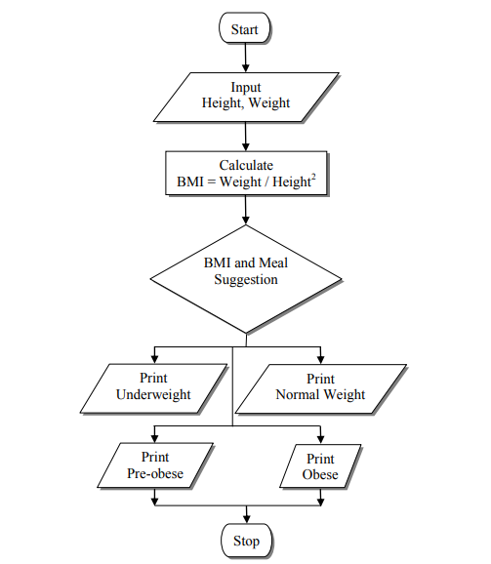

**Fig 4.1** Data flow Diagram for BMI Calculator

In the above Fig. 4.1, BMI Calculator also developed for meal suggestions on the application utilizing App. The suggestions for breakfast, lunch, and dinner are based on the number of body mass needed by the user, Calculator Android Application. Then, the third stage of BMI Calculator application development (Coding) was the implementation stage. Testing was performed concurrently with the programming of the application. Two inputs are demanded from the users which are height and weight. Once this information is inserted in the application, user’s BMI will be calculated based on the for mentioned formula.

# CHAPTER 5

**IMPLEMENTATION**

## 5.1 Algorithm

* + Start the BMI calculator program.
  + Display a welcome message and prompt the user to enter their height and weight.
  + Validate the user inputs to ensure they are numeric and within acceptable ranges.
  + Calculate the BMI using the formula: BMI = weight / (height^2), where weight is in kilograms and height is in meters. If the inputs are in different units, convert them to the appropriate units before performing the calculation.
  + Determine the weight classification based on the calculated BMI. Use predefined thresholds to categorize the BMI value into underweight, normal weight, overweight, or obese.
  + Display the calculated BMI and weight classification to the user.
  + Based on the weight classification, recommend an appropriate diet plan to the user. This could be a general recommendation or personalized based on specific weight goals or dietary restrictions.
  + Display the recommended diet plan to the user.
  + End the program.

**5.2 XML Designing and Implementation**

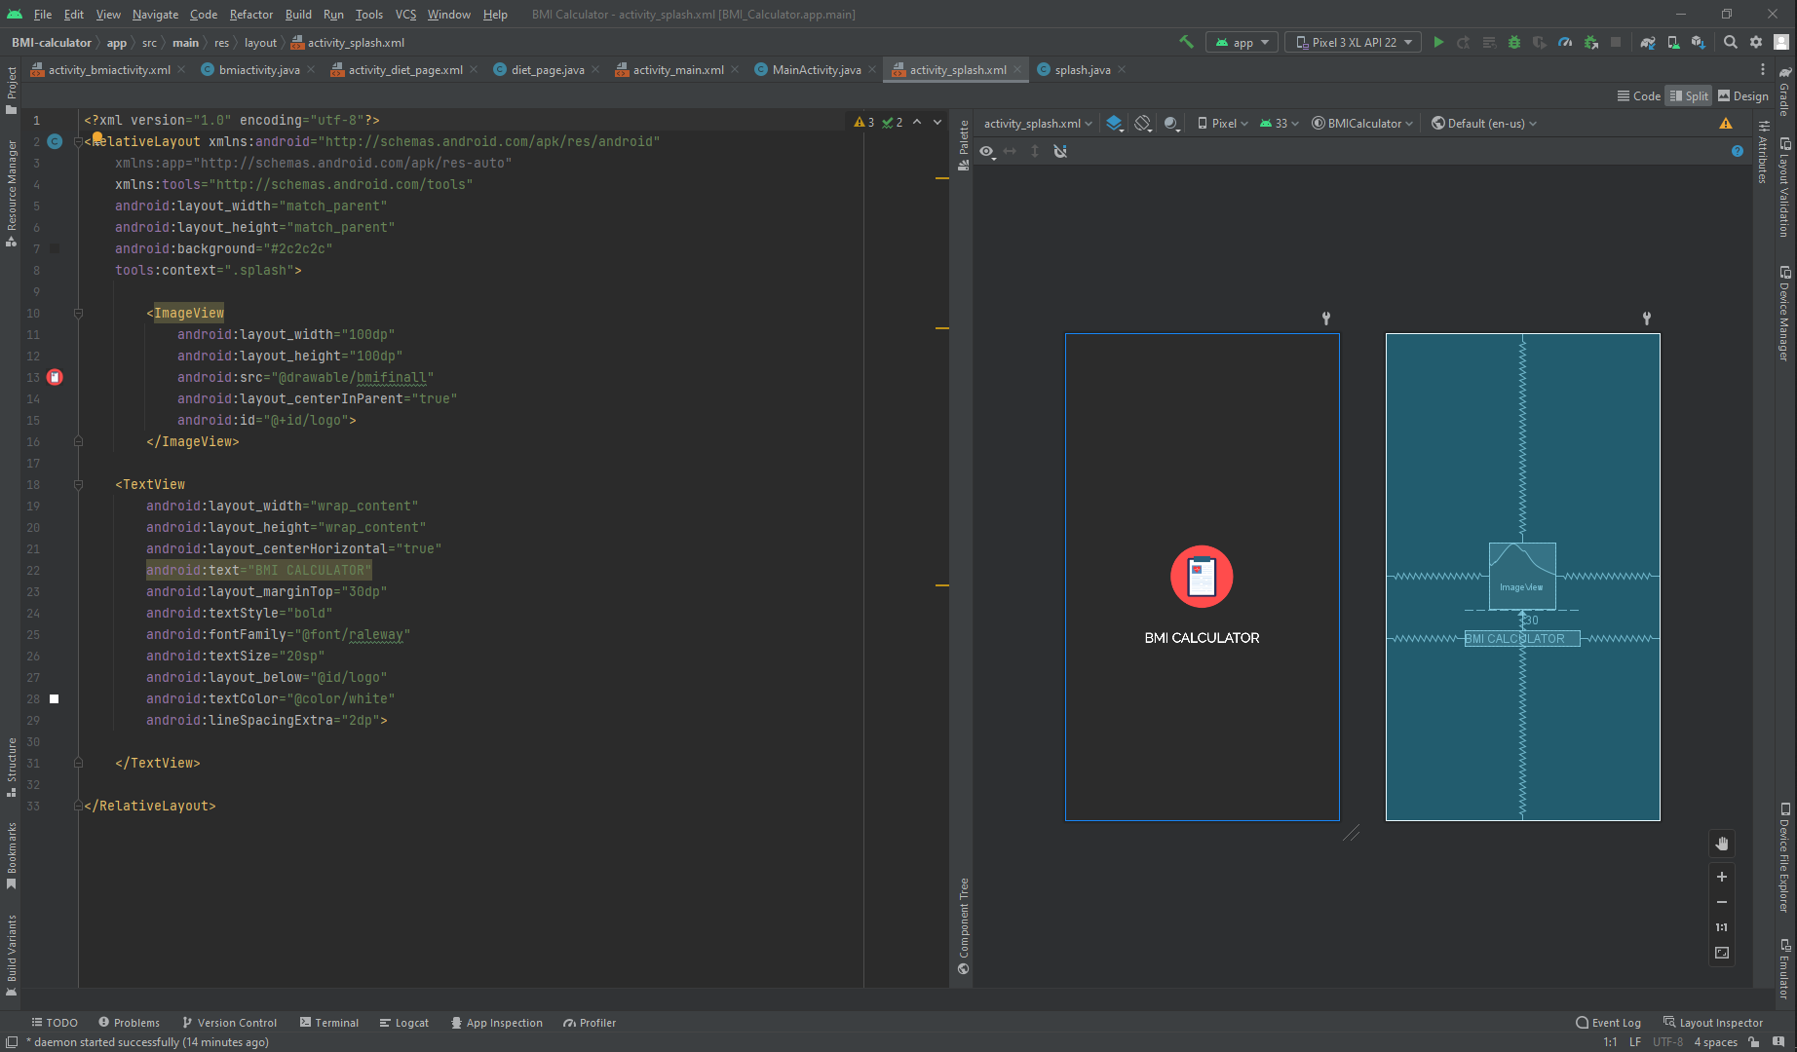

**Fig 5.1** Emulator screenshot of Splash Screen

The above snapshot shows the splash screen to open of App.

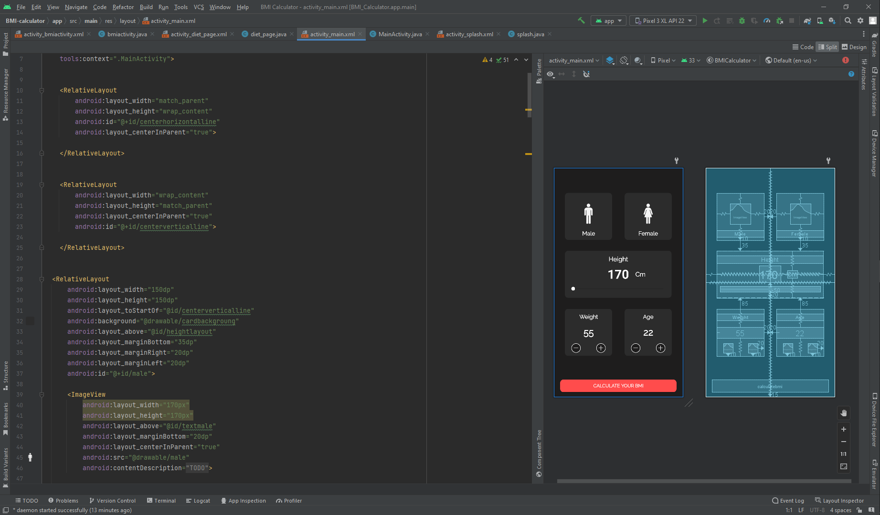

**Fig 5.2** Emulator screenshot of Home page

The above snapshot shows the Home page screen.

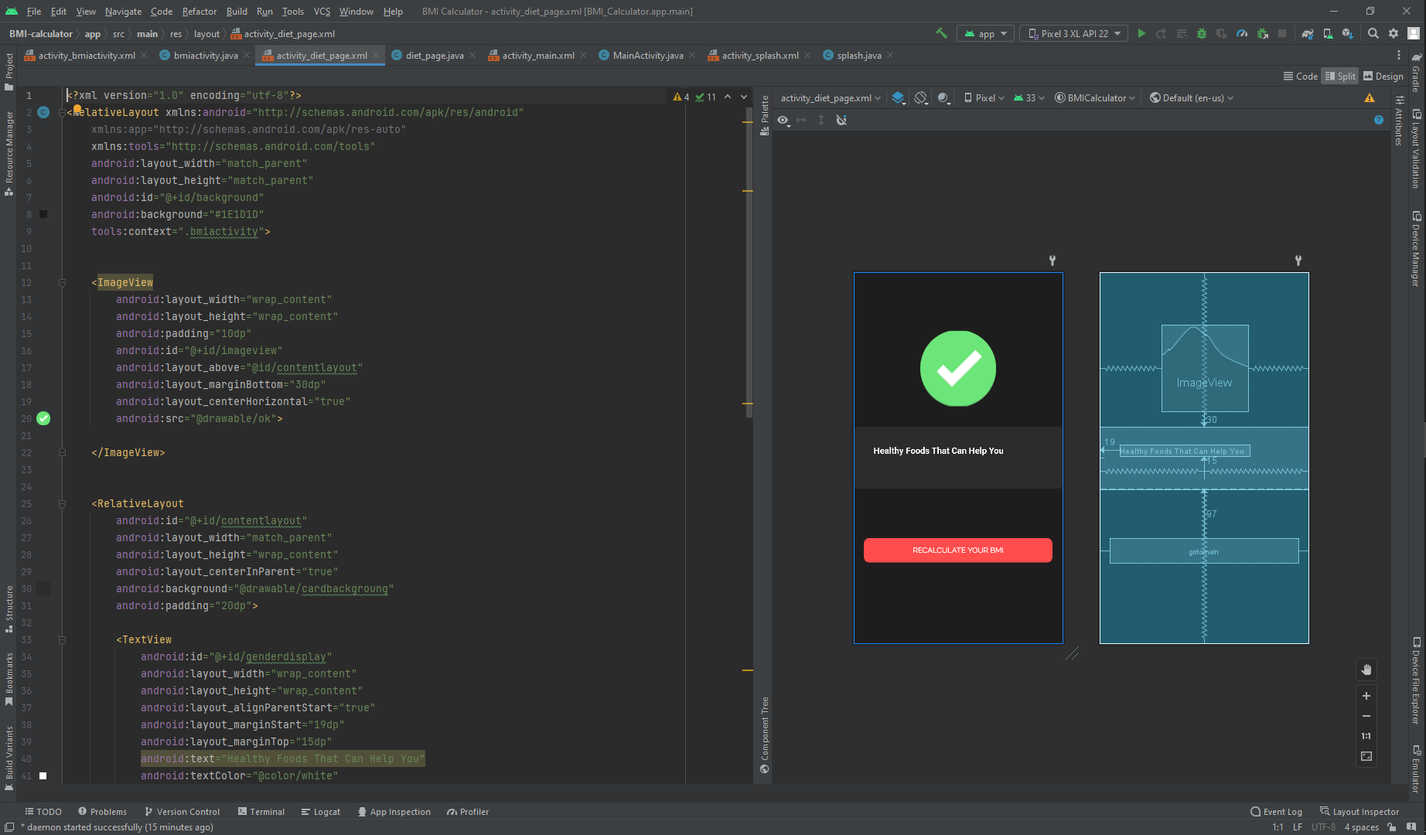

**Fig 5.3** Emulator screenshot of landing page result

The above snapshot shows the Landing page screen.

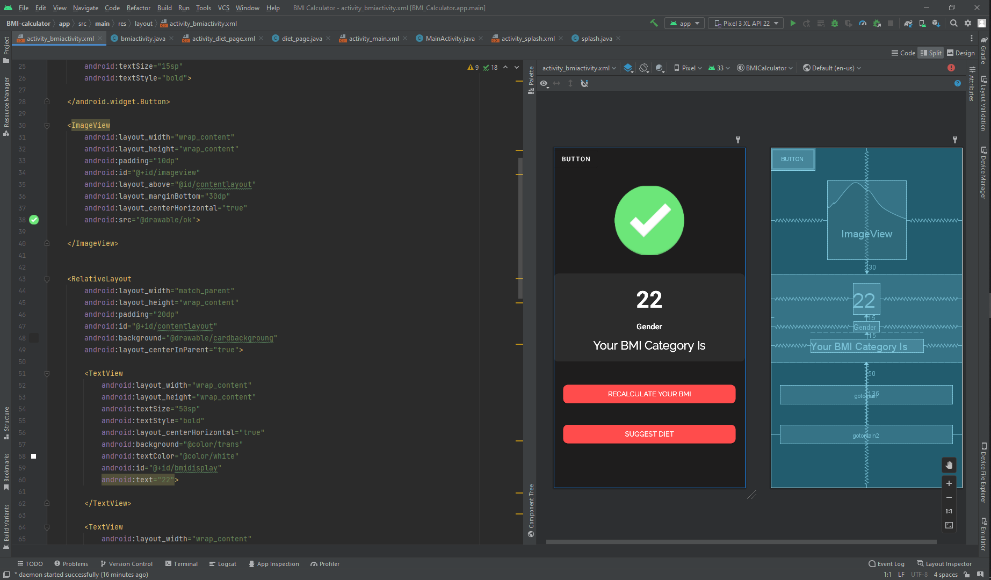

**Fig 5.4** Emulator screenshot of diet suggestion according to BMI value

The above snapshot shows the Landing page screen to show Diet Suggestion according to BMI value.

**5.3 Java Code Snippets**

intheight =Float.parseFloat(height); //BMI Calculation at every value

intweight=Float.parseFloat(weight);

intheight=intheight/100;

intbmi=intweight/(intheight*intheight);

mbmi=Float.toString(intbmi);

System.out.println(mbmi);

if(intbmi<16)

{

mbmicategory.setText("Severe Thinness");

// mbackground.setBackgroundColor(Color.GRAY);

mbackground.setBackgroundColor(Color.RED);

mimageview.setImageResource(R.drawable.crosss);

// mimageview.setBackground(colorDrawable2);

}

else if(intbmi<16.9 && intbmi>16)

{

mbmicategory.setText("Moderate Thinness");

mbackground.setBackgroundColor(R.color.halfwarn);

mimageview.setImageResource(R.drawable.warning);

// mimageview.setBackground(colorDrawable2);

}

else if(intbmi<18.4 && intbmi>17)

{

mbmicategory.setText("Mild Thinness");

mbackground.setBackgroundColor(R.color.halfwarn);

mimageview.setImageResource(R.drawable.warning);

// mimageview.setBackground(colorDrawable2);

}

else if(intbmi<24.9 && intbmi>18.5 )

{

mbmicategory.setText("Normal");

mimageview.setImageResource(R.drawable.ok);

// mbackground.setBackgroundColor(Color.YELLOW);

// mimageview.setBackground(colorDrawable2);

}

val=it.getStringExtra("data"); //meal suggestion

go=(Button) findViewById(R.id.gotomain);

float d=Float.parseFloat(val);

if(d<20.00)

{

img.setImageResource(R.drawable.low);

t.setText(" Milk ,Rice ,Dried fruits, Homemade protein smoothies");

}

if(d>=20.00)

{

img.setImageResource(R.drawable.high);

t.setText("Walnuts ,Avocado ,SunGold Kiwi,Beans");

}

go.setOnClickListener(new View.OnClickListener() {

@Override

public void onClick(View v){

Intent intent1 = new Intent(getApplicationContext(), MainActivity.class);

startActivity(intent1); } });

public class MainActivity extends AppCompatActivity {

TextView mcurrentheight;

TextView mcurrentweight,mcurrentage;

ImageView mincrementage,mdecrementage,mincrementweight,mdecrementweight;

SeekBar mseekbarforheight;

Button mcalculatebmi;

RelativeLayout mmale,mfemale;

int intweight=55;

int intage=22;

int currentprogress;

String mintprogress="170";

String typerofuser="0";

String weight2="55";

String age2="22";

@SuppressLint("ResourceAsColor")

@Override

protected void onCreate(Bundle savedInstanceState) {

super.onCreate(savedInstanceState);

setContentView(R.layout.activity_main);

getSupportActionBar().hide();

mcurrentage=findViewById(R.id.currentage);

mcurrentweight=findViewById(R.id.currentweight);

mcurrentheight=findViewById(R.id.currentheight);

mincrementage=findViewById(R.id.incrementage);

mdecrementage=findViewById(R.id.decrementage);

mincrementweight=findViewById(R.id.incremetweight);

mdecrementweight=findViewById(R.id.decrementweight);

mcalculatebmi=findViewById(R.id.calculatebmi);

mseekbarforheight=findViewById(R.id.seekbarforheight);

mmale=findViewById(R.id.male);

mfemale=findViewById(R.id.female);

mmale.setOnClickListener(new View.OnClickListener() {

@Override

public void onClick(View v) {

mmale.setBackground(ContextCompat.getDrawable(getApplicationContext(),R.drawable.malefemalefocus));

mfemale.setBackground(ContextCompat.getDrawable(getApplicationContext(),R.drawable.malefemalenotfocus));

typerofuser="Male";

}

});

mfemale.setOnClickListener(new View.OnClickListener() {

@Override

public void onClick(View v) {

mfemale.setBackground(ContextCompat.getDrawable(getApplicationContext(),R.drawable.malefemalefocus));

mmale.setBackground(ContextCompat.getDrawable(getApplicationContext(),R.drawable.malefemalenotfocus));

typerofuser="Female";

}

});

mseekbarforheight.setMax(300);

mseekbarforheight.setProgress(170);

mseekbarforheight.setOnSeekBarChangeListener(new SeekBar.OnSeekBarChangeListener() {

@Override

public void onProgressChanged(SeekBar seekBar, int progress, boolean fromUser) {

currentprogress=progress;

mintprogress=String.valueOf(currentprogress);

mcurrentheight.setText(mintprogress);

}

@Override

public void onStartTrackingTouch(SeekBar seekBar) {

}

@Override

public void onStopTrackingTouch(SeekBar seekBar) {

}

});

**CHAPTER 6**

**RESULTS AND DISCUSSIONS**

### 6.1 Snapshots of the project and description

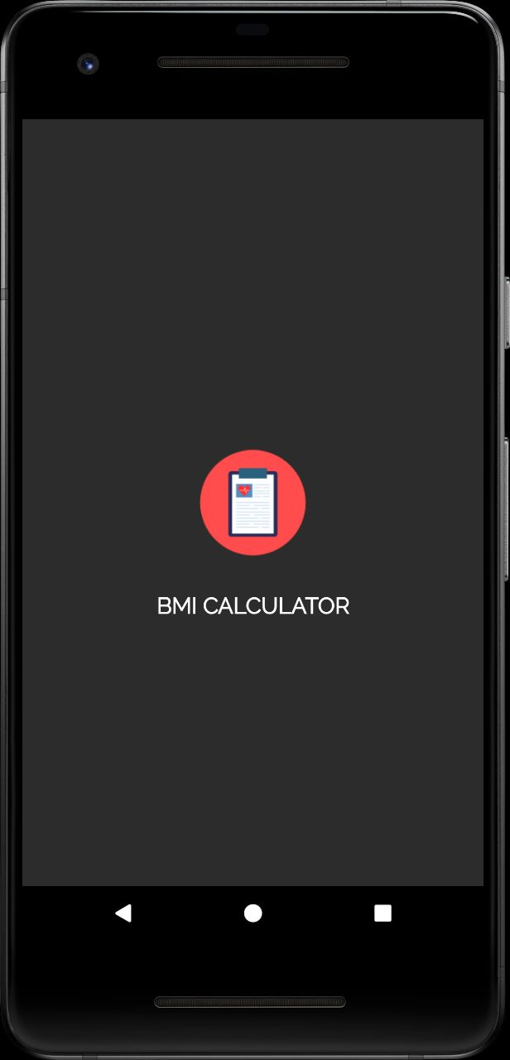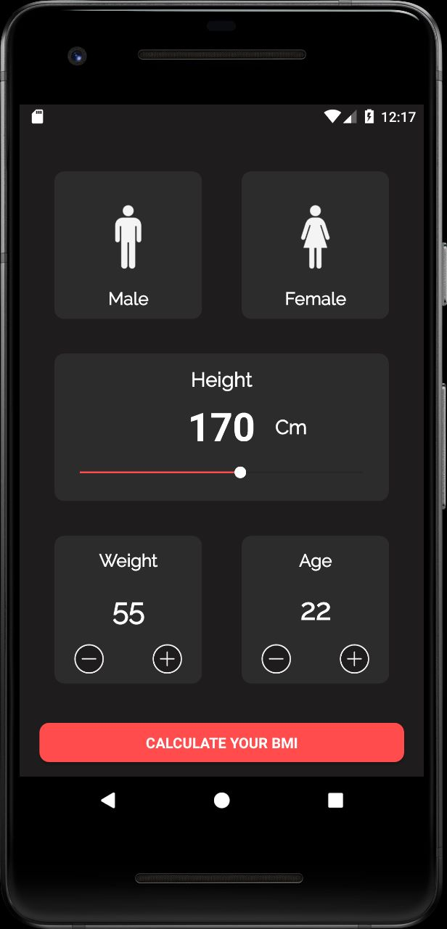

#### Fig 6.1: Splash Screen Fig 6.2: Home Screen

Fig 6.1 refers to splash screen when user open application .Fig 6.2 refers to home screen when user see the interface to give the inputs according to their preferences.

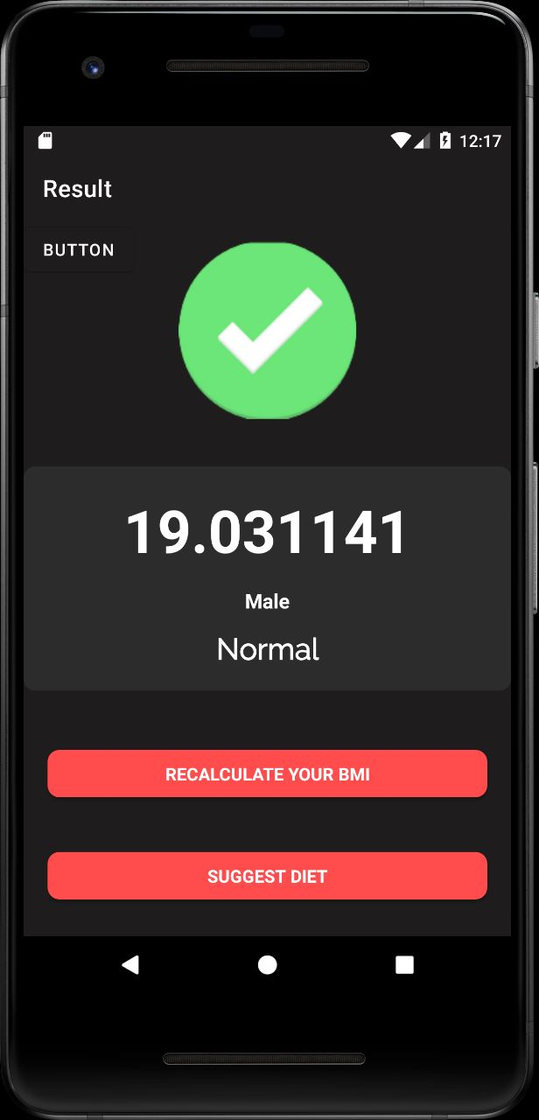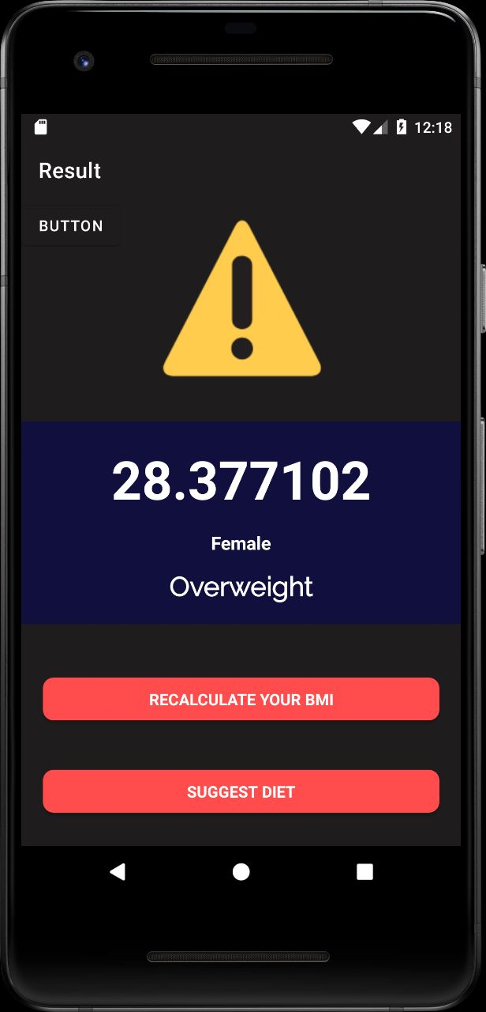

**Fig 6.3: Landing Page Screen 1 Fig 6.4: Landing Page Screen 2**

Fig 6.3 refers to landing page screen 1 when user give inputs as per preferences & show the result normal will come as a output (Male) .Fig 6.4 refers to landing page screen 2 when user give inputs as per preferences & show the result overweight will come as a output (Female).

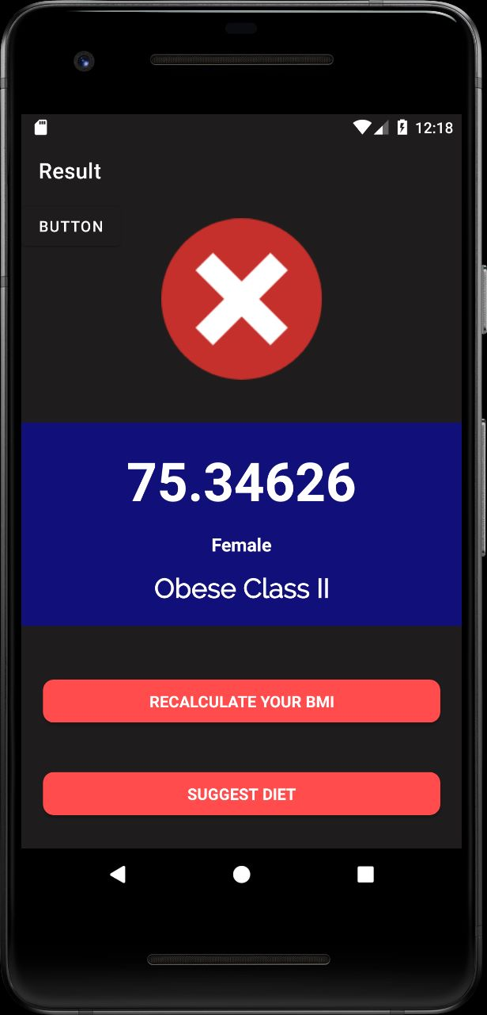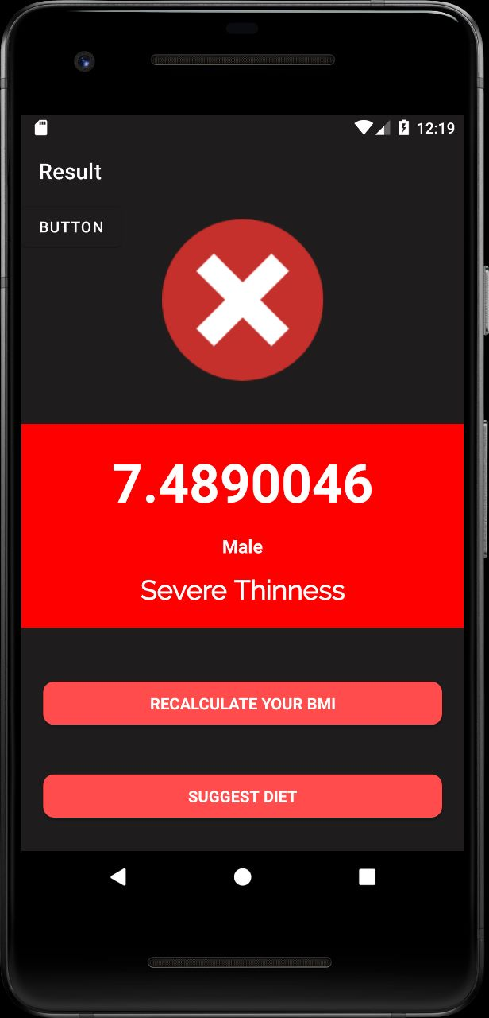

**Fig 6.5: Landing Page Screen 3 Fig 6.6: Landing Page Screen 4**

Fig 6.5 refers to landing page screen 3 when user give inputs as per preferences & show the result Obese Class II will come as a output (Female) .Fig 6.6 refers to landing page screen 4 when user give inputs as per preferences & show the result Severe Thinness will come as a output (Male).

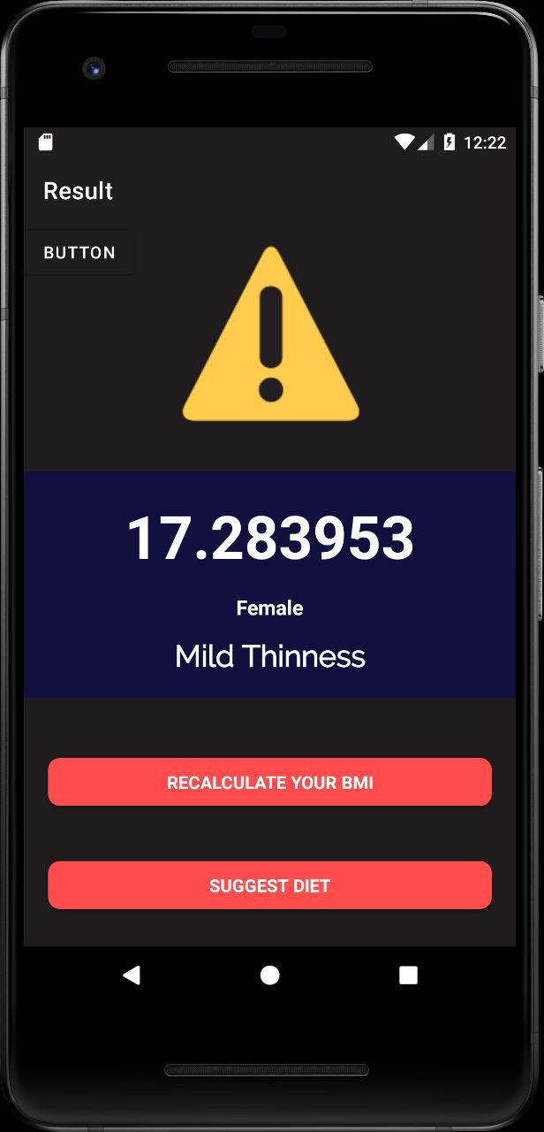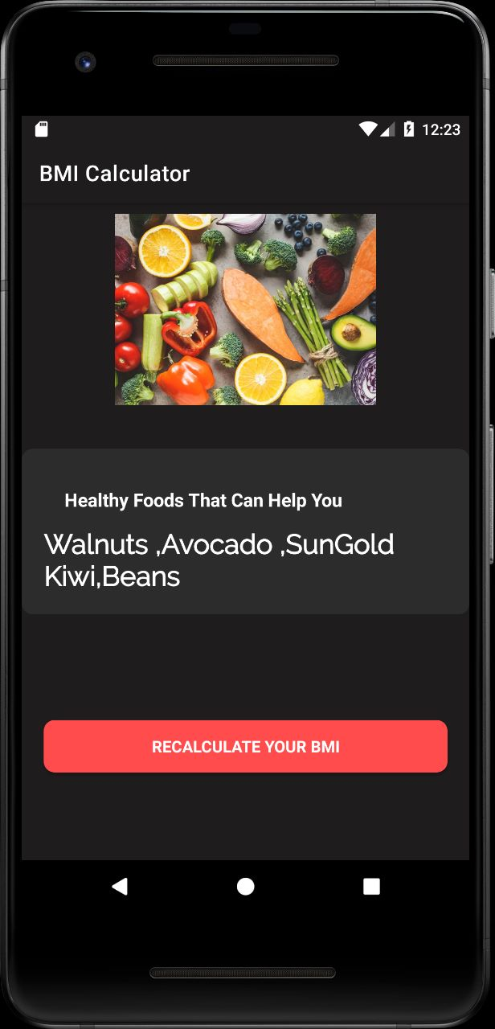

**Fig 6.7: Landing Page Screen 5 Fig 6.8: Landing Page Screen 6**

Fig 6.7 refers to landing page screen 5 when user give inputs as per preferences & show the result Mild Thinness will come as a output (Male) .Fig 6.8 refers to landing page screen 6 when user give inputs as per preferences & give the suggestion of meals according to body weight.

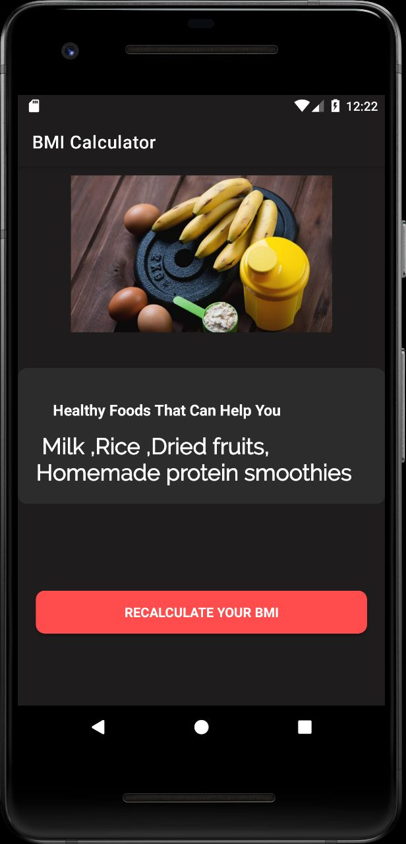

**Fig 6.9: Landing Page Screen 7**

Fig 6.9 refers to landing page screen 6 when user give inputs as per preferences & give the suggestion of meals according to body weight.

**CHAPTER 7**

**CONCLUSION**

In conclusion, a BMI (Body Mass Index) calculator is a valuable tool for individuals to assess their weight status and gain insights into potential health risks associated with weight. By calculating BMI based on height and weight measurements, individuals can determine whether they are underweight, have a normal weight, are overweight, or fall into the obese category. This information serves as a reference point for evaluating weight status and can guide individuals towards adopting healthier lifestyle choices. The BMI calculator not only provides a numerical measure but also offers weight classification categories, allowing users to better understand their weight status in relation to health risks. Additionally, the calculator can serve as a motivational tool by encouraging individuals to set and monitor their weight management goals. It raises awareness about the importance of maintaining a healthy weight and can initiate discussions with healthcare professionals for further guidance. However, it is crucial to remember that the BMI calculator is just one component of a comprehensive health assessment and should be interpreted alongside other factors such as body composition, muscle mass, and overall health.

Moreover, Android Studio allows for seamless integration with other technologies and APIs, enabling developers to incorporate additional functionalities like social media sharing, bookmarking, and search options. This enhances the app's usability and provides users with more ways to interact with and share news content. Furthermore, Android Studio offers robust tools for performance optimization and bug fixing, ensuring that the news app runs smoothly and efficiently on a wide range of Android devices. This improves the user experience and minimizes any potential issues or crashes.

## REFERENCES

[1]. https://developer.android.com/docs Android Studio [2].https://developer.android.com/studio

[3]. <https://www.javatpoint.com/android-tutorial>

[4]. <https://www.geeksforgeeks.org/>

[5]. https://www.geeksforgeeks.org/body-mass-index-calculator-in-android-studio/